Curriculum Vitae
M.VAIRAMUTHU 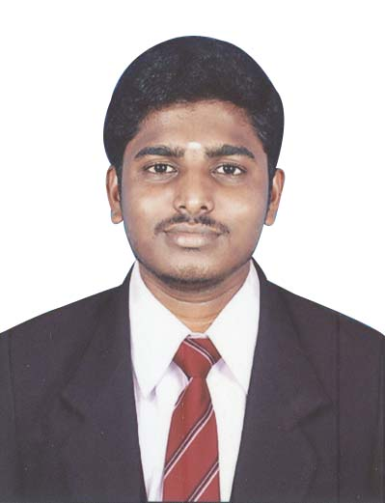
vairamuthu19490@gmail.com
+91-9600324367

Objective:
Seeking a fulfilling and challenging position that allow utilization of my skills and provide experience in System Administration area. To build my career with leading corporate of hi-tech environment with committed & dedicated people

Summary:

- Established track record with 4 years above of experience in helping organizations efficiently.
- Installation of software, patching, upgrading, Configuring and maintenance of operating system( Windows XP, and Windows Server 2000/2003)
- Familiarity with Microsoft Office, printing, and Windows networking.
- Extensive experience of working on various hardware platforms like Intel Pentium, Dell, HP, Compaq, Acer, Lenovo.
- Hardware issue, Troubleshooting, Data Recovery, assembling, Toner Refilling
- Laptop Service, Printer Ribban Change, Network Crimping and office Work.

Educational Qualification:

Course / Degree | Name of the Board / University | Period | % Of Marks
BCA | Madurai Kamaraj University | Dec 2012 | 47
XII Standard | Govt Higher Secondary School, Rajapalayam. | April 2007 | 54.2
X Standard | Govt Higher Secondary School, Rajapalayam. | April 2005 | 72

Certification:

Diploma in Computer Hardware and Networking (D.C.H.N) Sudar Community College, Srivilliputhur.

Professional Experience

Period | Employer | Location | Designation
Jan 2016 to till now | SHRI.T.P Textiles (p) ltd | Rajapalayam | EDP& Office Staff
Jun 2015 to Dec 2015 | IT Delights | Chennai | Computer Service Engineer
Oct 2014 to Jun 2015 | BS Apparel | Tirupur | EDP& Office Staff
Feb 2010 to May2013 | Bharath Niketan Engineering College. | Theni | System lab technician
Jan 2009 to Jan 2010 | KB System and Service | Rajapalayam | Computer Service Engineer

Detailed Professional Experience:
Bharath Niketan Engineering College. Theni, Feb 2010 to May 2013

- Coordinate hardware and software installations and upgrades to ensure work is performed in accordance.
- Troubleshooting the OS problems and Hardware issues.
- Provided help and support in solving hardware and software problems of the Students.
- Created and implemented recommendations to improve scalability and performance.

Computer Service Engineer in KB System and Service, Rajapalayam from Jan 2009 to Jan 2010.

- Involved in Computer Service of customer by visiting their place and prepared the requirement specification and proposed solutions for implementing the same.
- Involved in production support for maintaining the system developed and resolved the complexities and bugs raised by customers efficiently and effectively on time.
- Extensive experience of working on various hardware platforms like Intel Pentium, Dell, HP, Compaq, Acer, Lenovo.
- Os and Software, Drivers installation
- Hardware issue, Troubleshooting, Data Recovery, assembling, Toner Refilling
- Laptop Service, Printer Ribbon Change, Network Crimping and office Work

Personal Details

Father’s Name : V.Murugesan.

Date of Birth : Apr 19th 1990.

Marital Status : Single

Languages Known : Tamil, English.

Permanent Address : 2/71, South street ,
Saminathapuram,
Thombakulam(po),
Rajapalayam(Tk),
Virudhunagar(Dt).
Pin Code: 626117

Declaration:

I hereby declare that above given information are true best of my knowledge.

Place: Rajapalayam

Date: (M.VAIRAMUTHU)

